Year 5 Topic 1
Creation and Covenant
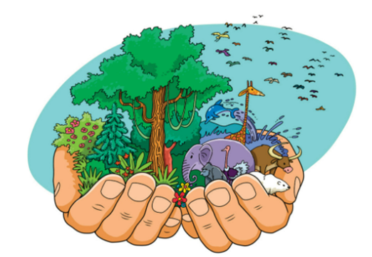 | In this unit we will hear the Moses story, focusing on the two key events of the call and the covenant:  • The Burning Bush (Ex 3:1-15)  • The Sinai covenant and the Ten Commandments (Ex 19:3-8, 20:1-17)  • Jesus’ summary of the law (Matt 22:36-40)  We will know that  A covenant is a binding agreement between God and human beings, which makes them his people and that God made several covenants throughout history – with Noah, Abraham, Moses, and David.  That God gives the Ten Commandments to help human beings live good and happy lives and that Jesus teaches that the most important commandments are to love God and to love other people.  Also to know that Catholic Social Teaching helps us to see that loving our neighbour demands a commitment to social change and transformation: ‘We profoundly belong together and are fundamentally dependent on one another’. (YC 321)  We will learn that  sin is the deliberate spoiling of our friendship with God and each other, and we can develop habits that will help us accomplish what is good. These habits are called virtues.  CELEBRATE / LIVE
 |  Discern  What does ‘you shall not steal’ mean? Or what if there were eleven Commandments?  What does loving our neighbour means for Christians today?
  Key Vocabulary | Start | End
  Covenant
  Moses
  Exodus
  Sinai
  Commandments
  virtues
  grace

 | By the end of this unit:
U5.1.1. | Retell the Moses story, focusing on the two key events of the call and the covenant (the Burning Bush (Ex 3:1-15); the Sinai covenant and the Ten Commandments (Ex 19:3-8, 20:1-17)).
U5.1.2. | Make links between the Ten Commandments and Jesus’ summary of the law in Matthew’s Gospel (22:36-40).
U5.1.3. | Correctly use developing specialist vocabulary to describe what a covenant is, recognising that God made several covenants throughout history, e.g., with Noah, Abraham, and Moses.
U5.1.4. | Use developing specialist vocabulary to show how the Ten Commandments help human beings live good and happy lives.
U5.1.5. | Correctly use developing specialist vocabulary to describe sin as deliberately spoiling our friendship with God and each other
U5.1.6. | Know that a virtue is a positive habit that helps people live a good life. (RVE)

